PT 8612
HD-SD Serial digital Test signal Generator

The PT 8612 HD-SD Serial digital Generator can be installed in the PT 5300 HD-SD Sync Generator.
Packing list:
Check that the PT 8612 option package contains the following items:
 | Description: | Item | Quantity
 | Nut for BNC | 2422 034 17419 | 4
 | Lock washer for BNC Connector | 2422 034 17421 | 4
 | Pan Head Screw M3x4 | 2522 178 31056 | 8
 | Ribbon Cable with micro 20P | 4008 105 04030 | 1
 | Hexagonal Spacer M3 L=9 mm | 4008 107 27440 | 8
 | Hexagonal Spacer M3 L=6 | 4008 107 27450 | 8
 | HD-SD signal Gen. Assy | 4008 109 91410 | 1
 | Master PROM , PT5300 s/n > 030693  Master PROM, PT5300 s/n < 030693 | 4008 002 08082  4008 002 08101 | 1  1
 | PT8612 option type plate |  | 1

The system is “plug and play” meaning that when the unit is mounted no configuration is needed in order to enable the PT 8612.
However, to ensure proper correspondence between physical outputs on the rear plate and the output description shown in the display, the unit has to be installed in the right positions and connected correspondingly.
NOTE:
To ensure adequate cooling of the FPGA on the board a heat-transferring pad is mounted between the FPGA’s cooling fin and the bottom of the chassis.
If an additional PT8612 has to be installed, it has to be mounted in the position of the PT8611, Tri-level generator. The Tri-level generator is then moved to the upper row of boards.
In doubt, please contact factory.

For the first produced PT5300, special attention has to paid during installation. Also a new master PROM has to be installed on the mainboard.
If rearplate is different from rear plate drawing on next page, the factory has to be consulted

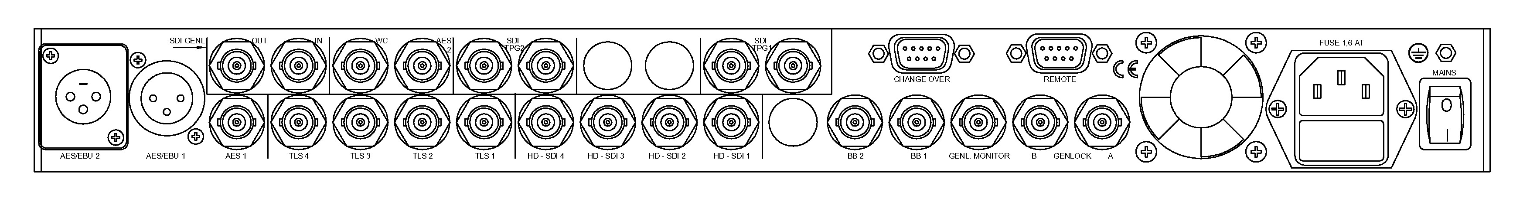
The drawing below shows the rear plate of the PT5300.
Rear plate lay out

Installation procedure
- Open the PT 5300 by removing the top cover.
- The PT8612 HD-generator has to be installed next to the Tri-level generator.
BNC positions are labeled HD-SDI 1 to HD-SDI 4
- Remove the plastic blinds from the back panel for the BNC connectors.
- Install the 8 hexagonal spacers (length of 9mm) in the corresponding studs in the main frame (Photo 1).
- Mount the ribbon cable from the PT 8612 printed circuit board to the PT 5300 main board
The guide pins in the connectors should fit into a hole in the PCBs.
- Place the PCB board on the spacers with the BNC connectors through the back of the generator (Photo 2).
The board is placed with component side down with the heat-conducting foam against the bottom of the cabinet. Apply a gentle pressure on the board to press the PCB against the spacers.
- Mount the 8 hexagonal spacers (length = 6mm) to secure the board, do not tighten.
- Mount the lock washers and nuts on the BNC connectors, and tighten the nuts.
- Tighten the 8 hexagonal spacers fixing the PCB..
- Mount the top cover on the PT 5300.
- Turn on power, and observe that the menu includes the HD-SDI Test Pattern Generator.
- Place the option type plate on the side of the generator in order to make later identification possible
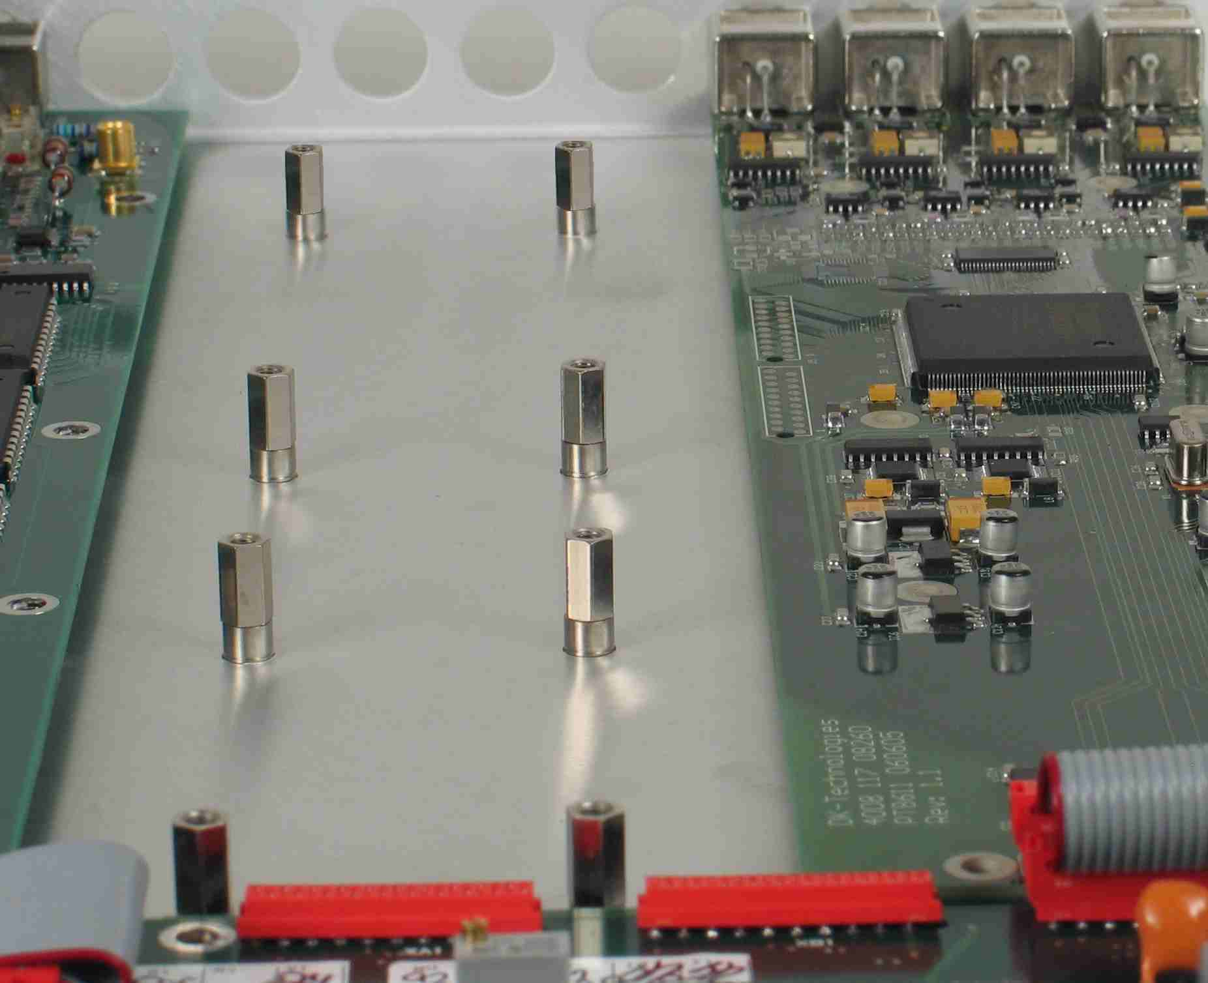
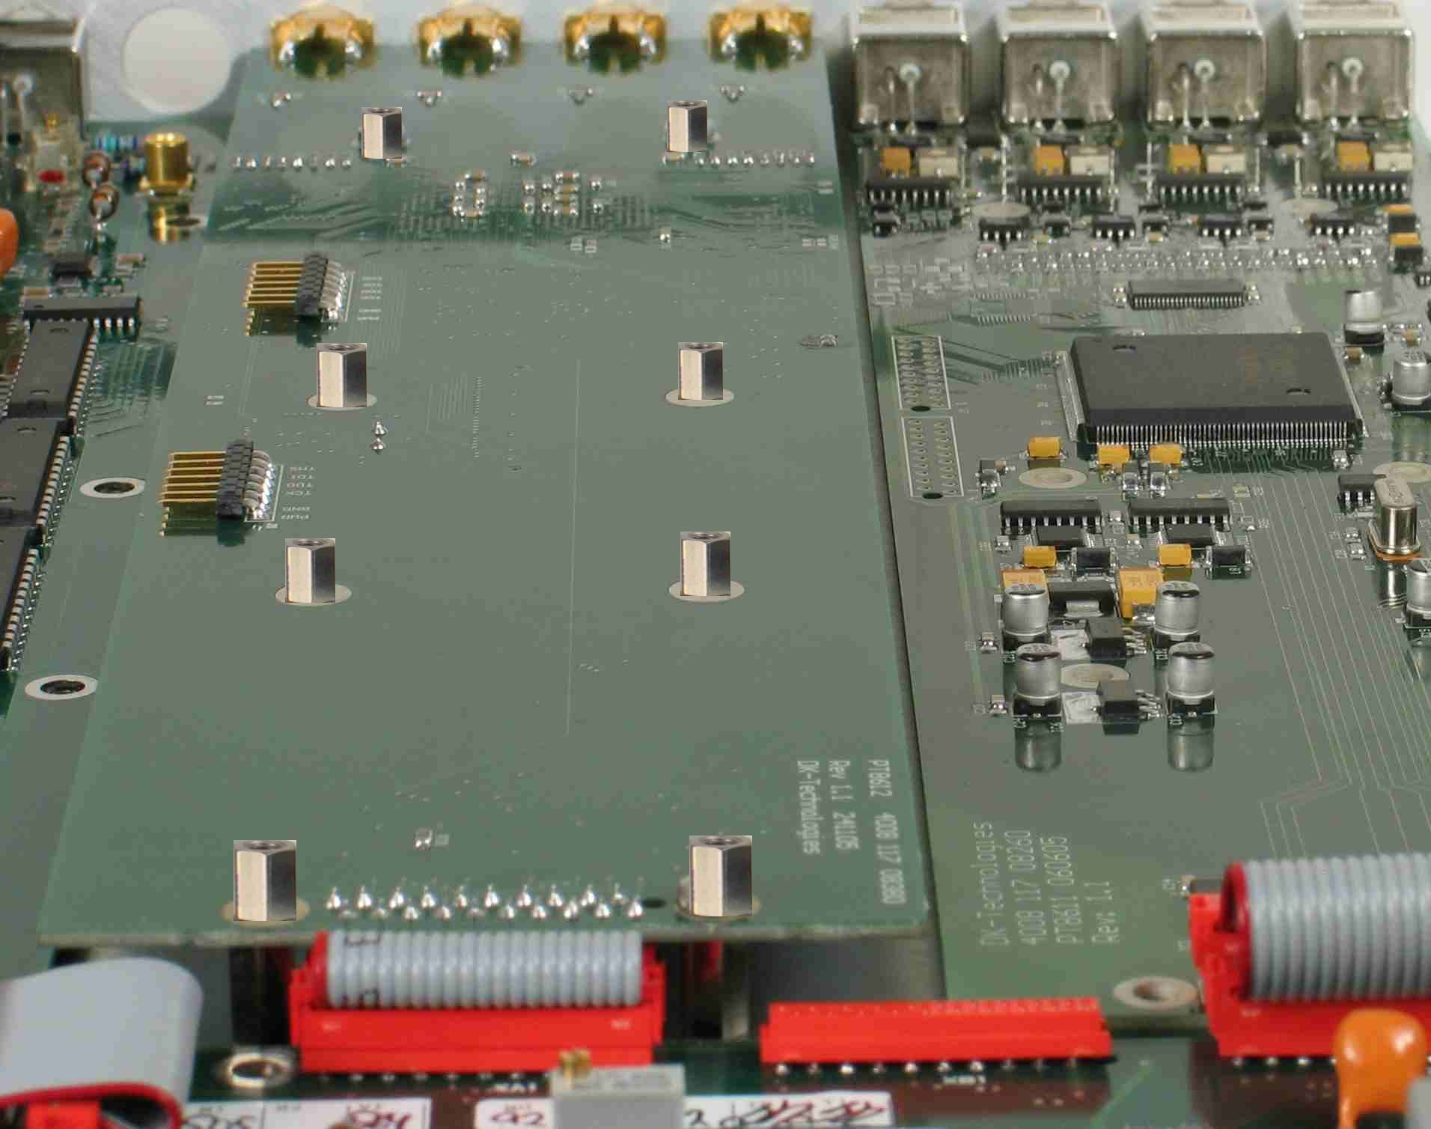
NOTE:
If an extra PT8612 has to be mounted it has placed in the positions for the Tri-level board.
Photo 1: Mounting distance pieces Photo 2: Mounting board

Installation of new master PROM
Remove the mounted PROM in the shown position.
Mount the new master PROM carefully taking care of polarizing it correctly.
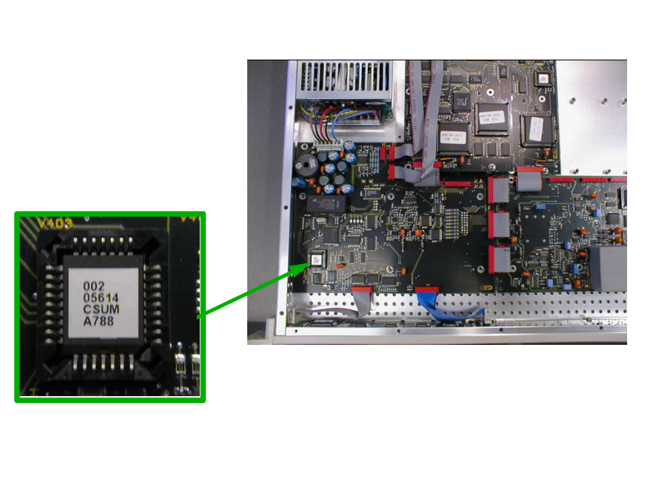
Picture 1: The positioning of the master processor PROM. The lower right corner on the PROM is indicated by a cut in the chip. (Note, that code number on actual PROM may differ from Photo)

